Lemon-Thyme Chicken Salad

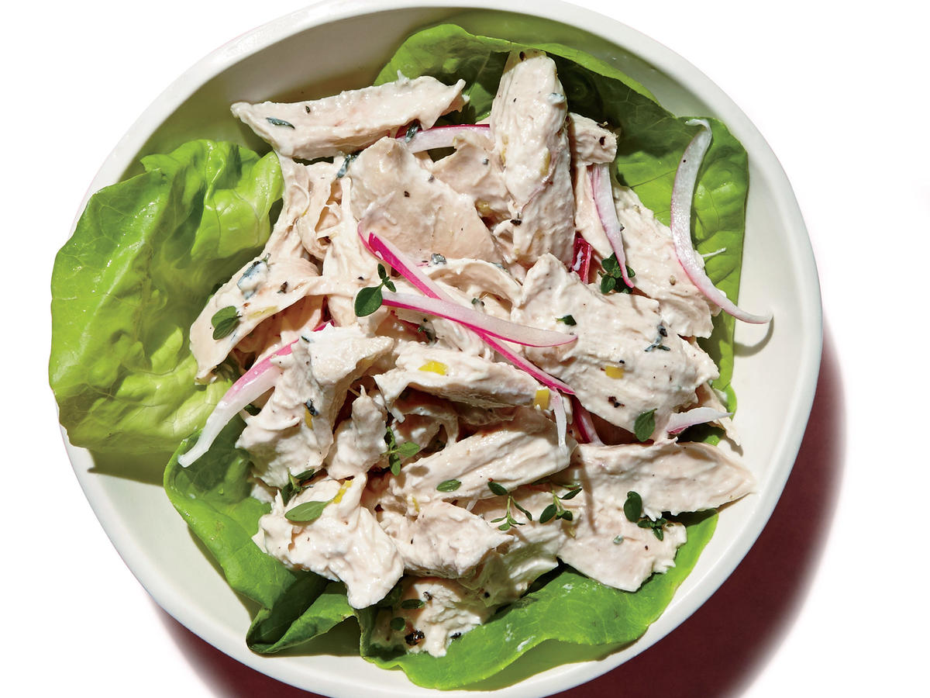
Ingredients
- 4 cups water
- 2 bay leaves
- 9 ounces skinless, boneless chicken breast
- 1/4 cup plain 2% reduced-fat Greek yogurt
- 1 tablespoon olive oil
- 1 1/2 teaspoons fresh thyme leaves
- 1 teaspoon grated lemon rind
- 1/4 teaspoon kosher salt
- 1/4 teaspoon black pepper
- 2 tablespoons slivered red onion
GET INGREDIENTSPowered by Chicory
Nutritional Information
- Calories 236

- Fat 11g

- Satfat 2g
- Unsatfat 7g

- Protein 31g

- Carbohydrate 2g

- Fiber 0.0g

- Sodium 307mg

- Calcium 3% DV

- Potassium 13% DV

- Sugars 1g

