Advanced
Beef and Primal Cuts

The Various Cuts of Beef
Beef cuts can be fairly confusing and if you have ever wondered ‘what is a brisket’? or ‘what is a flank steak? The best cuts of beef can be situational and perhaps highly opinionated, and it is important to understand the different cuts of beef before we can really break down what the best cuts of steak are.
Beef is often considered a premium cut due to relative costs to pork and chicken. Beef is a versatile protein, up there with the versatility of chicken. Beef is typically the hardest of the common proteins to cook due to the many numbers of beef cuts, the many numbers of cooking methods that can be used, and the amount of attention required to cook a cut of beef to perfection. Deciding what the best cuts of steak are for a specific application can come down to several factors.
We’re going to talk about the basics of the cuts of beef and what you need to know to ensure that you are using your foundational knowledge to produce the very best beef dishes you can. Cooking the various beef cuts isn’t exactly hard, but without using the proper cooking methods you will have a larger tendency to over-cook, under-cook, have it turn out tough, and generally not making the best out of all beef cuts.
The general rule for hind-quarter is most of them can be used with a dry-heat method as much of the meat you’ll find from the hind-quarter is of high quality and coming from the loin, hip, and flank.
When in doubt, it is always recommended that you judge a cut by its appearance. A cut with nearly zero fat marbling will generally require a moist-heat cooking method to ensure tenderness. A cut with a lot of fat marbling, such as a rib-eye steak, will do very nicely grilled or pan-fried.
Primals
- Chuck
- Rib
- Loin
- Sirloin
- Round
- Brisket
- Plate
- Flank
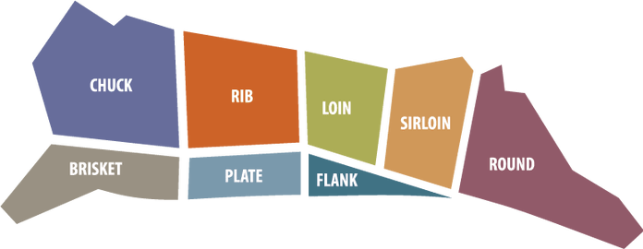
Chuck Primal
The chuck is a side of beef that can be found in the front quarter. This primal cut of beef can be defined as the most prolific, having the most amounts of cuts by far. Many of the cooking methods for this primal of beef tend to be moist-heat, as the marbling is sparse and the muscling is very well developed. Towards the rear of the primal (Center to the animal), you will find some cuts that will do well with some dry-heat cooking methods.
You’ll want to be sure you have the proper cooking tools for these types of beef cuts, and recommend investing in a proper slow-cooker or braiser.
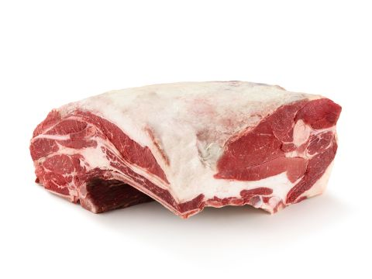
Chuck Beef Cuts
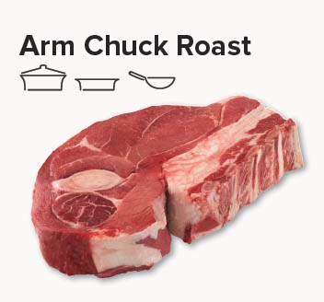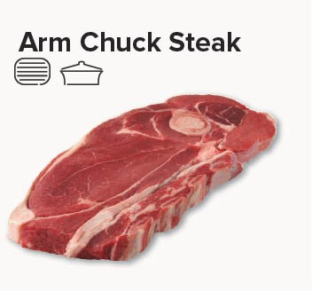
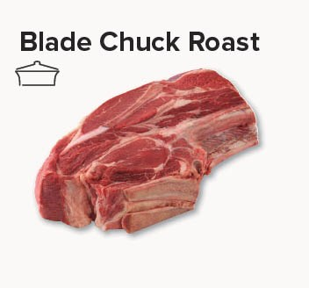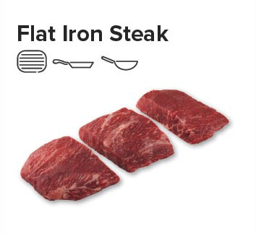
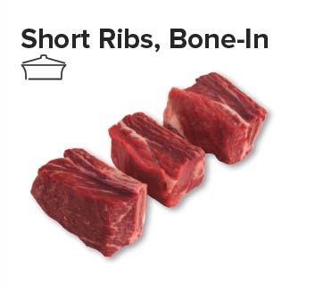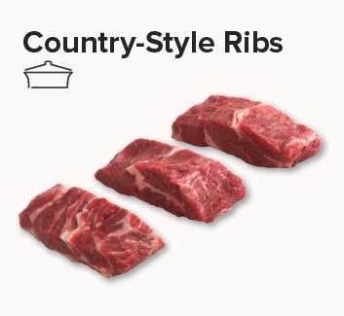

Rib Primal
The Rib Primal is a side of beef cut that is is the beginning of the highly coveted cuts that many people enjoy, such as the Ribeye Steak and Ribeye Roasts. Because of this, the rib primal cuts of beef tend to be more expensive and the best beef cut results are used in dry-heat cooking methods cooking method, such as grilling, roasting, or skillet.
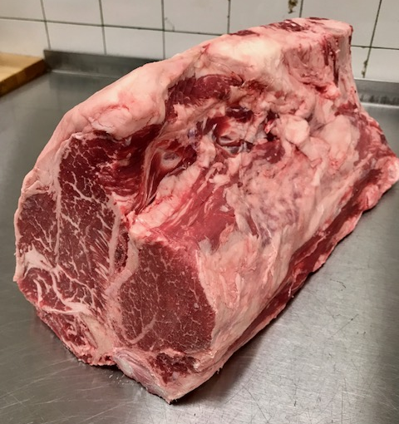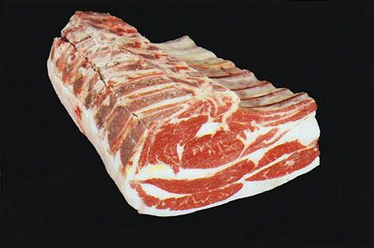
A cow has 13 ribs per side. Butchers refer to these ribs in ascending order from the front of the animal to the back. The first five ribs (1 through 5) are in the chuck section, the next seven (6 through 12) are the rib section, and the 13th is part of the loin. Ribs 6 through 12 are sold as Prime Rib.
Prime Grade versus Choice Grade
Prime is the highest quality grade that the U.S. Department of Agriculture assigns to beef available to consumers. It indicates that the meat is heavily marbled with intramuscular fat (10 to 13 percent), which refers to the streaks of white fat between muscle fibers and which make it particularly flavorful and tender.
Choice, the second-highest grade of beef, is the grade issued to moderately marbled meat.
Prime-grade prime rib is a premium-quality roast often sold at high-end markets and butchers. Not surprisingly, it’s more tender and flavorful than choice-grade prime rib, and tends to have an expensive price tag, about 25 percent more than choice prime rib.

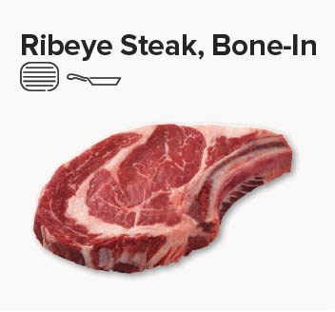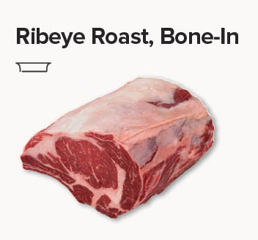
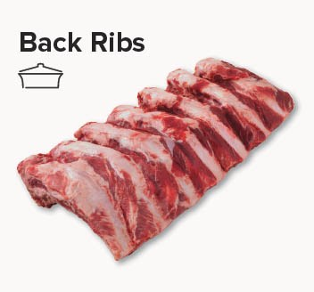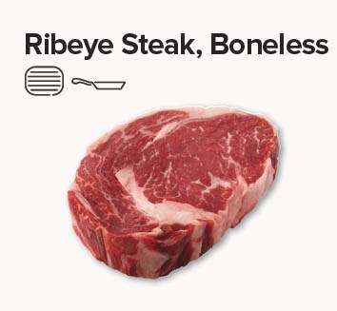

Loin Primal

The Loin Primal has the most expensive side of beef cuts you can find and is sought after for its tender and marbled texture. Here you will find high-end cuts such as the Porterhouse Steak, Filet Mignon, and New York Strip.

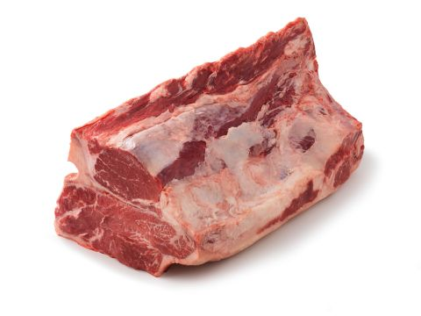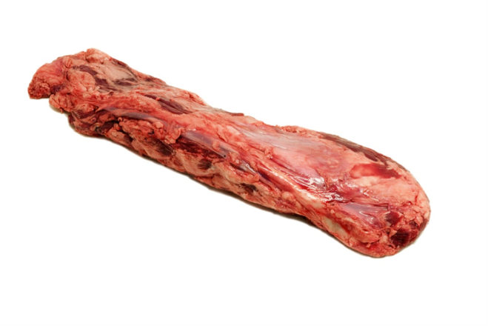
Beef Tenderloin uncleaned
Beef Strip Loin with Tenderloin

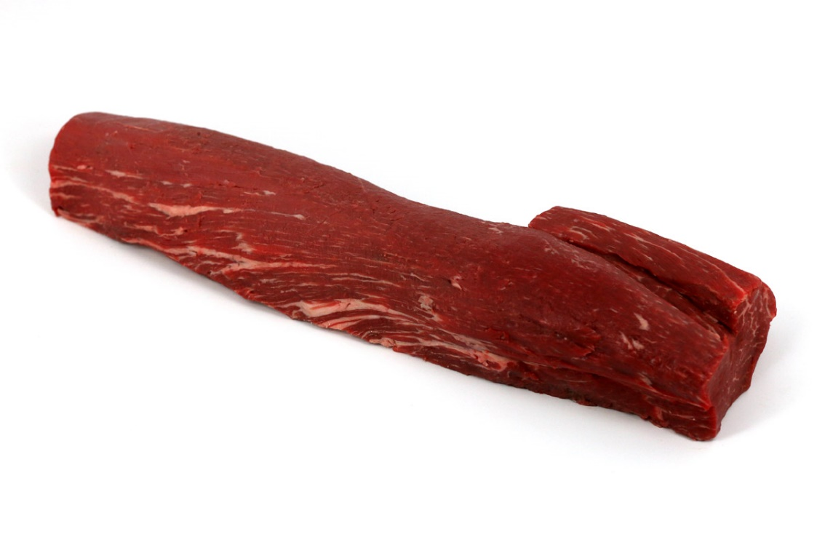
Beef Tenderloin cleaned and trimmed

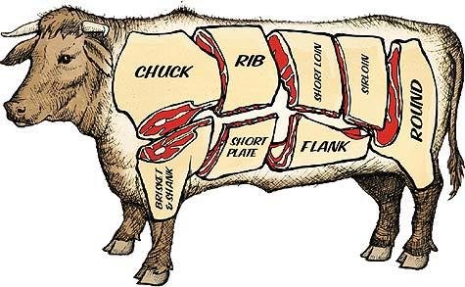
The tenderloin extends from the short loin back into the sirloin. It's interesting to note that if the tenderloin is removed, there can be no T-bone or porterhouse steaks. Both of these steaks include a section of the tenderloin muscle.
The tenderest cut of beef is the beef tenderloin and it is found within the loin. This is where we get filet mignon, which is made from the very tip of the pointy end of the tenderloin. Chateaubriand is made from the center cut of the tenderloin.
The tenderloin extends from the short loin into the sirloin. The pointy end is actually situated within the short loin, and the section in the sirloin is sometimes called the butt tenderloin. Even so, butchers will often remove the entire tenderloin and sell it whole or as individual steaks and roasts.
Beef tenderloin should only be cooked using dry-heat methods, such as grilling and broiling. The meat is already super tender, so long cooking times are unnecessary. Keep it quick and the heat high.
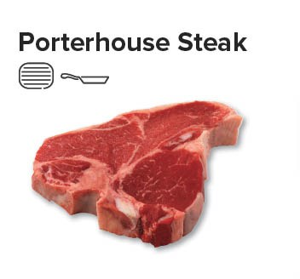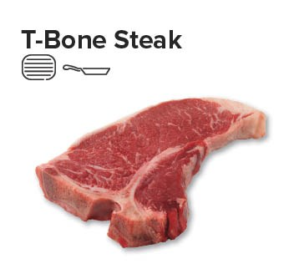
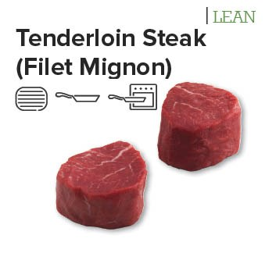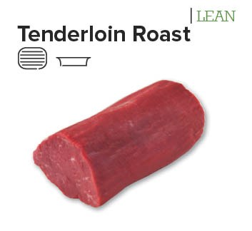

Sirloin Primal
The Sirloin will be where you’ll find flavorful roasts, such as the top sirloin, and tender steaks. The hip is where you’ll find the cheaper sides of beef roasts, such as the inside round, eye of round and outside rounds. The outside round is best when braised, while the inside produces the best roast.

Beef sirloin is another large section of the carcass that runs from the 13th rib all the way back to the hip bone and from the backbone clear down to the flank (or belly). Since the sirloin is closer to the rear leg of the animal, the muscles get a bit tougher. Proper cooking ensures that these types of cuts don’t toughen and loose moisture.
The sirloin is almost always broken down into two boneless wholesale cuts: the top sirloin butt and bottom sirloin butt. This is done by cutting along the natural seam between the primary muscle of the top sirloin, and the knuckle, a group of three muscles that make up the bottom.
After separating it from the top sirloin, the bottom sirloin is usually divided into three main components: the tri-tip, ball tip, and flap, which do well with roasting and barbecuing (and they are sometimes made into ground beef).

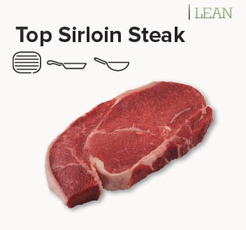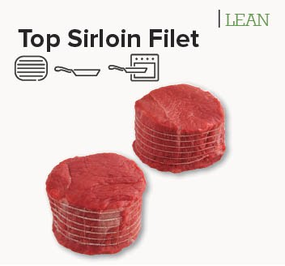

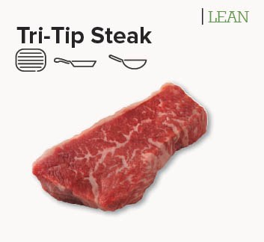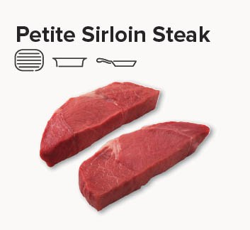

Brisket Primal

Brisket is a beef cut taken from the breast section of the cow beneath the first five ribs, behind the foreshank. Taken from the area around the breastbone, the brisket is basically the chest or pectoral muscle of the animal, which supports much of the animal's weight. Consequently, brisket can be a large cut of meat, between 3 and 8 pounds, and is rich in the connective tissue collagen, which makes the meat tough. A brisket is quite long and is usually divided in half and sold as two different pieces of meat. The characteristically thick, coarse-grained meat needs a lot of time and low-temperature cooking to break down and tenderize.

Brisket is frequently used for making pot roast, and it's the traditional choice for corned beef. Another very popular technique for preparing brisket is to slow cook it in a barbecue or smoker.

How to Cook Beef Brisket

Since brisket is a very tough cut, the best methods for cooking are those that cook at lower temperatures for a longer period of time, such as braising and smoking. Brining is also an option, which will turn the piece of brisket into a corned beef; after the meat is cured in a brine, it is slowly simmered until tender.

Whether braised, brined, or smoked, brisket needs plenty of time to cook. A smoked brisket, Texas style, is rendered soft and delicious after eight to 12 hours at 225 F. A braised brisket, Jewish style, also cooks at a low temperature for at least three hours, as it absorbs the liquid from vegetables and the collagen fibers break down.
